Chapter 19, Problem 14.

For the two-port network shown in Fig.19.75, show that
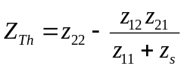
and
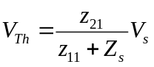

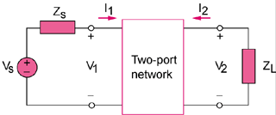

Figure 19.75
For Prob. 19.14.

